How to Drive a Manual Car
Name
Contact Information

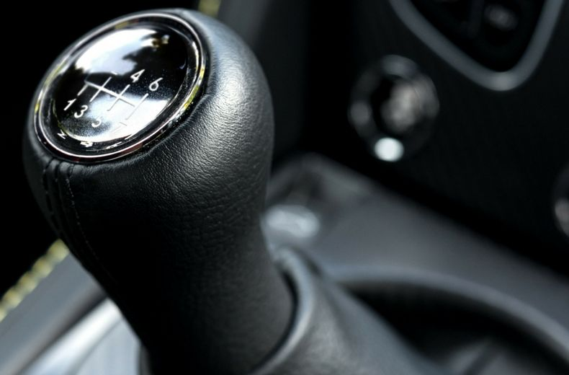

Table of Contents
Step One: Understanding your manual car…………………………………………………………………………………………...…3
Step Two: Ignition and Acceleration……………………………………………………………………………………4
Step Three: Clutch Protection……………………………………………………………………………………….5-6
Step Four: How to 'heel-and-toe'….............................................................................................6
List of Figures
Figure 1: Understanding your manual car ………………………………………………………………………………………………..3
Figure 2: Ignition and acceleration……………………………………………………………………………...……4
Figure 3: Heel and toe……………………………………………………………………......6

Step One: Understanding your manual car
On the average, manual cars are equipped with three pedals: accelerator, brake and clutch (in that order).
Manipulating the accelerator and brake pedals is relatively easy- push the brake pedal to slow down (the harder it is pressed, the faster your speed reduces), while stepping on your accelerator revs up your engine and increases speed, corresponding with how firm you press on it.
What brings much difference, and increases difficulty compared to the automatic car, is the clutch pedal. The clutch is in essence, a twin set of plates connecting the drive wheels to the engine. In effect, stepping down on this pedal disconnects the engine from the wheels.

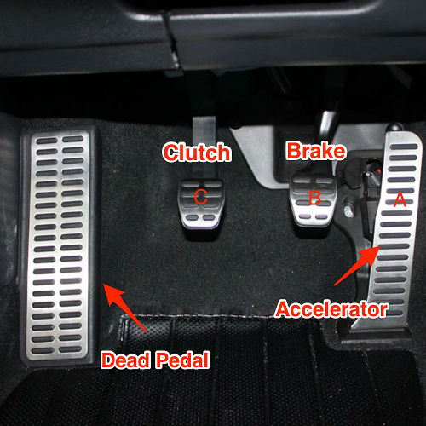
Figure 1
Step Two: Ignition and Acceleration
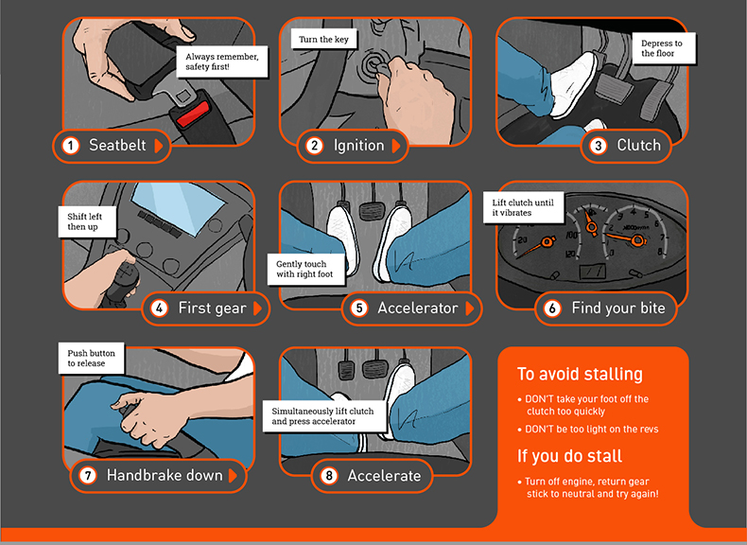
Figure 2
- Upon getting into the car, put on your seatbelt.
- Insert your key in the ignition while turning it till the engine starts.
- Press on the clutch.
- Move the gear stick to first gear.
- Using your right foot, step down onto the accelerator and gently rev up the engine.
- Follow this with lifting the clutch with your left foot right until it begins to gently vibrate. This is the moment when the clutch plates align, and it is referred to as the ‘bite point’.
- Upon this, disengage the hand brake, and the car starts moving.
- Increase the revs slowly and gradually by lifting your foot off the clutch, until you gain full control using the accelerator pedal.
NOTE: A quick point to note is that quick lifting off the clutch will not rev up the engine enough and this will lead to stalling- in this case, the engine cuts out, and you get red glow lights on your dashboard. In this event, step on the brakes, shut off your engine and revert your gear stick to neutral and repeat the process.
Step Three: Clutch Protection
With time, you get used to the car’s clutch and establish understanding as to its bite point and the number of revs needed to move it.
This sounds hard, but it is one thing you’ll develop a natural feel for in the course of your driving.
In the absence of care, you may wear out your clutch prematurely.
During hilly manoeuvres, limit your press on the accelerators as this wears out the clutch plates unnecessarily. A minimum amount of revs is needed to keep the car going and being gentle enough, most cars can move without pressing on the accelerator.
Also in the case of stoppage especially during traffic jams, do not keep pressure on your clutch whilst still in gear, a common temptation. This mounts pressure on the clutch release bearing, and if done regularly, wears it out. Alternatively, just stop and engage the handbrake only using the clutch when you are ready to move.

Step Four: How to 'heel-and-toe'
With good practice driving a manual car, you may desire to acquire advanced driving techniques such as the “heel-and-toe”.
All you have to do is rest the left section of your right foot on the brake pedal and use the right half of it to blip the accelerator. This has the benefit of enabling you to rev match as you get to braking while working down through your gearbox. Rev matching is a technique that enables a driver to match the chosen gear with the speed they are driving at.
It is a satisfying skill that may cut seconds of your lap time if you decide to go on track day.
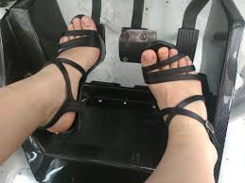
Figure 3

Glossary
Revs: Increase in engine speed by pressing the accelerator.
Engage: Move a part of a machine such as the gear or handbrake into a needed position.
Manoeuvres: Navigating a problematic terrain.

